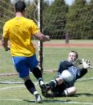

Get Ready Soccer players to win the
L.A. City Championship!

Join us on Monday 09/18, Wednesday 09/20, and Thursday 09/21 for our annual try-outs. Try-outs will begin at 3:30-5:30 pm. in the
Baseball Field.

Soccer TRY-OUTS

Come to ROOM 300 to register!

http://fremonths.org/apps/staff/show_staff.jsp?REC_ID=32859&upREC_ID=6048&rn=9174

